DR. AMBEDKAR COLLEGE, DEEKSHABHOOMI, NAGPUR

DATE: 1.09.2023 to 16.09.2023
NAME OF THE PROGRAM: 15 DAYS INTERDISCIPLINARY COURSE ON FORENSIC SCIENCE AND CRIMINAL JUSTICE SYSTEM
NAME OF THE ORGANISING COMMITTEE: THE CRIMINAL LAW CLUB DEPARTMENT OF LAW AND CODE F SOLUTIONS PVT. LTD.
NUMBER OF ATTENDEES: 110 (GIRLS: 65 APPROX ; BOYS – 45)
NAME OF THE VENUE: HYBRID (SESSIONS CONDUCTED ONLINE VIA ZOOM AND PRACTICALS OFFLINE)

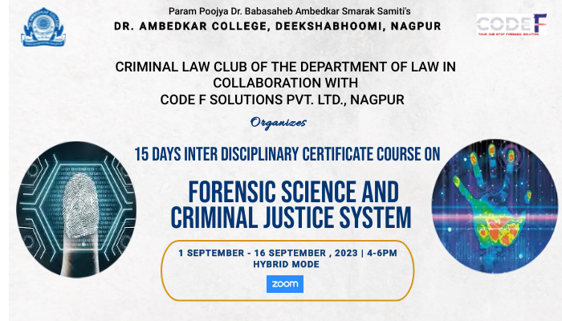

The Criminal Law Club of the Department Of Law, Dr. Ambedkar college, Deekshabhoomi, Nagpur launced under its flagship a 15 days Interdisciplinary short term certificate course on 1st September 2023 on Forensic Science and Criminal Justice System in collaboration with Code F Solutions Pvt. Ltd., Nagpur. A unique objective of this course is to juxtapose the legal principles and propositions within the realm of forensic science and criminal justice system and to develop a cumulative and comprehensive understanding of the technological aspects of forensic science in the context of criminal laws.

On 1st September, 2023 the Certificate Course was inaugurated in the presence of the Chief Guest Mrs. Vaishali Bhushan Mahajan, Assistant Director, Regional Forensic Science Laboratory, Nagpur, Guest of Honor Dr. A. Mukherjee from GMC, Nagpur, Principal of the college Prof. Dr. Mehere, Head of the Department of Law, Prof. Dr. H.V.Menon, Course Director Prof. Mrs. Sandhya Kalamdhad, Course Co-ordinator from Code F solutions pvt, Ltd. Mr. Shubham Shahu. The first lecture was held physically on 1st September, 2023 by Prof. Dr. A. Mukherjee Sir, GMC, Nagpur on mechanical injuries and its medico-legal aspects. He further discussed about difference between forensic science and forensic medicine. He discussed about difference between legal injury and medical injury and various types of injury like Abrasion, contusion, laceration, incised wound, chop wound, stab and puncture wound, defense wound and firearm injury.

On 2nd September, 2023, Dr. Manish Malhotra Sir, CFSL- Bhopal took the Lecture and elaborated on the concept of crime, scene of crime, Method of Preservation and Trace Evidence. He explained with the help of Crime Triangle which includes Offender, Place of Crime and Victim and explained 5 major steps involved in crime scene management i.e. Render Aid, Establish Security, Survey, Documentation and Processing.

On 3rd September, 2023, Adv. Chetan Dhore Sir, Highcourt, Nagpur, spoke on the Role and importance of forensic Evidence. He further explained definition of evidence, scientific/ expert’s evidence.

On 4th September, 2023, Dr. Ashish Badiye Sir, HOD, IFSC Nagpur, spoke on introduction and application of forensic science in the Criminal Justice system. He spoke on principles of forensic evidence like principle of exchange, individuality, comparison, probability, circumstantial facts, progressive change , analysis. Further, he spoke about history of forensic science and modern techniques of investigation.

On 5th September, 2023, Dr. Neeti Kapoor Ma’am, Assistant Professor- IFSC Nagpur, took the session and gave the lecture on fingerprint examination. She explained the importance of fingerprint, properties of fingerprint, uses of fingerprint on a crime scene, where all it can be of use. She further discussed on the nuances of Types, categories, pattern, identification of fingerprint.
On 5th September, 2023, SHUBHAM SHAHU Sir, Director of Code-F solutions took a session for students discussing about Career opportunities in Forensic Science. He explained how forensic science has a great future and the doors of opportunities it would open and how it is an upcoming field.
On 7th September, 2023, Dr. Rajesh R. Patil Sir, took the session and spoke aboutwhat is forensic science and its 3 core branches- physical, chemical and life science. He further discusses about types of evidence, examination of glass and evidence, physical examination, significance of glass and glass fracture evidences, techniques of examination and lastly, soil and fibre evidence.
On 8th September, 2023, Mr. ShrikantArdhapurkar Sir, Cyber Expert, Nagpur took the session and spoke about multimedia forensics and gave introduction on digital forensics, types of forensic examination like database, e-mail, malware, memory, mobile, network and techniques used for identifying computer crimes.
The second session on 8th September was conducted by, Pallavi Mohanty Mam, CFSL, Kolkata on fingerprint classification of fingerprints and elaborated on types of fingerprints. She further discussed on 10 digit fingerprint classification system, minutiae’s, matching of fingerprints and steps for matching fingerprints.

On 9th and 10th September, 2023 Practical sessions were conducted by the department of Biotechnology and Biochemistry of Dr. Ambedkar College, Deeksha Bhoomi and Code-F Solutions in the Labs of Biotechnology department, which was a great insight for the students. The sessions showed pollen profile analysis, species identification by radial immune diffusion, Sex determination using skeletal remains, DNA fingerprinting and analysis, Blood stain Identification using phenolphthalein assay, blood stain identification using teichmann test, saliva stain analysis, determination of species using ABO blood groups. On 10th student witnessed a crime scene investigation, hair and semen analysis.

On 11th September, 2023, Dr. Ritvik Shedge, NFSU, Triupura took the session and gave an introduction on forensic medicine, need of forensic medicine, identification of human remains, assessment of injuries, toxicology, postmortem examination/autopsy, dying declaration/deposition.

The second session of the day on 11th September, 2023 was conducted by Dr. Ritesh Shukla, Ahemdabad University on the topic of Forensic toxicology, fields of toxicology, what is the role of forensic toxicology, discussion on drug vs poison and further on classification of poisons.

On 12th September, 2023, Dr. Milind Panchbhai, AP, IFSC Nagpur, took the session and spoke on collection, preservation and analysis of biological evidence in crime. He elaborated on DNA Profile i.e. maintaining the integrity of biological evidence/original form of evidence, packaging and storing biological evidence and importance of timing in biological evidence retention.

The second session on 12th September, 2023, was conducted by Dr. Pradip Hirapure, Nagpur who took the session of handling of Biological evidences and elaborated on Locard’s Principle, Crime Scene Investigation team which includes police officers, CS Investigator, Recorder, Sketch Artist, Photographer, collection experts, 6’S of CSI i.e. Securing, seperating the witness, scanning, steering, sketching, searching.

On 13th September, 2023, Dr. Manoj Bhandarkar, FSL, Thane took the session and dicussed about forensic investigation in crime scene, he discussed on principles of foreign science, division of forensic laboratories and elaborated on the working i.e. General analytical and instrumentation divisioin, biology/serology division, DNA division, ballistics division, toxicology division, prohibition and excise division, physics division etc.

On 14th September, 2023, Mr. Harendrakumar Bamburde, IFSC, Nagpur took the session on introduction to crime scene management. He discuused on steps to scientific examination of a crime scene, initial response to crime scene, role of investigation officer, 4 major documentation in CSI focuses on note taking, videography, photography, sketching.

Mr. Mahendra B. Limaye, Nagpur who took session on Introduction to Cyber Laws, Information Technology Laws and further discussed about civil offences and criminal in the Act, conducted the second session on 14th September.

On 15TH SEP, HARSHITA BAJAJ MAM, Research Scholar, NFSU Delhi, took the session and discussed about ON CONCEPT AND THEORIES OF CRIMINOLOGY. She spoke about criminal psychology and reasoning behind committing psychology.

On the Day of Valedictory, a documentary depicting few live experiments was shown to the participants by Prof. Hirapure. The Chief Guest for The valedictory session was Adv. Jameel Khan. He threw light on the topic intersection of forensic science and criminal justice system with special reference to proposed recent amendments in Criminal Law, 2023. Dr. Mehere in her address congratulated the participants for their insightful learning and stated tthat the course must have been a stimulating and invigorating experience for all the participants . Dr. Menon emphasized that with the intellectual content of the syllabus, inquisitiveness in the teaching by different speakers was maintained and it was an enriching learning process for all the participants. Dr.S.P.Kalamdhad sincerely acknowledged every One for Joining Valedictory Session of Certificate Course and also thanked all the Guest speakers for their insightful and enlightening teaching. She congratulated all the participants for successfully completing the Certificate Course.

The course co-ordinators from the Department of Law who worked hard for the successful culmination of the 15 days certificate course were Dr. Vaishali Sukhdeve, Ms. Shilpa Rathod, Ms. Sarika Kamdi, Ms. Anusha Patre, Ms. Seema Sharma and Ms. Navjyot Saluja.

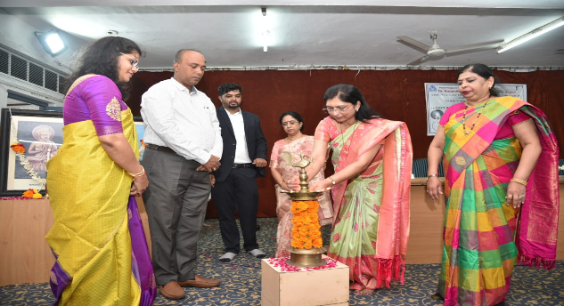

INAUGURAL SESSION

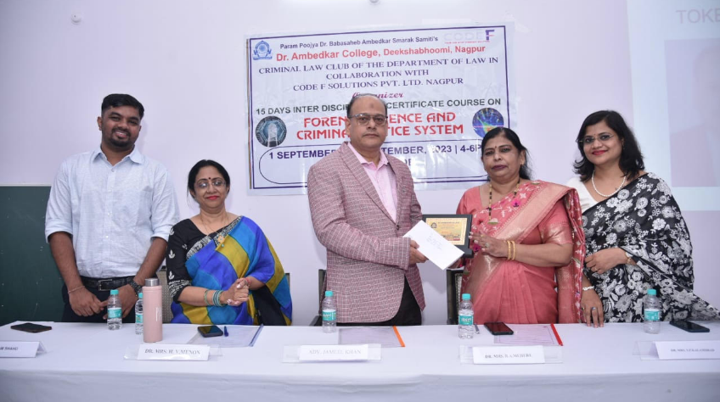

VALEDICTORY SESSION

